Supporting Information
Developmental control and plasticity of fruit and seed dimorphism in the annual Brassicaceae Aethionema arabicum

Teresa Lenser, Kai Graeber, Özge Selin Cevik, Nezaket Adigüzel, Ali A. Dönmez, Christopher Grosche, Marcel Kettermann, Sara Mayland-Quellhorst, Zsuzsanna Mérai, Setareh Mohammadin, Thu-Phuong Nguyen, Florian Rümpler, Christina Schulze, Katja Sperber, Tina Steinbrecher, Nils Wiegand, Miroslav Strnad, Ortrun Mittelsten Scheid, Stefan A. Rensing, Michael Eric Schranz, Günter Theißen, Klaus Mummenhoff, Gerhard Leubner-Metzger

Plant Physiology, November 2016, Vol 172
The following Supporting Information is available for this article:
Fig. S1 MrBayes tree of the Aethionemeae.
Fig. S2 RaxML tree of the Aethionemeae.
Fig. S3 Fruits of Aethionema arabicum fall into two discrete clusters.
Fig. S4 Phylogenies of Ae. arabicum orthologs of A. thaliana fruit developmental genes
Fig. S5 The temperature-induced shift in fruit morph ratio is brought about by changes throughout the whole plant.
Table S1 Geographic origin of Aethionemeae species used for the phylogeny.
Table S2 List of species and respective sequences used for gene phylogeny reconstruction.

Table S3 List of primers used for quantitative RT-PCR analysis.
Data S1 Sequence alignment underlying species phylogeny.
Video/Movie S1 Moisture induced pedicel movement of an Aethionema arabicum infructescence.

Fig. S1 MrBayes tree of the Aethionemeae. Green edges: posterior probability > 0.8. Orange edges: posterior probability < 0.5.

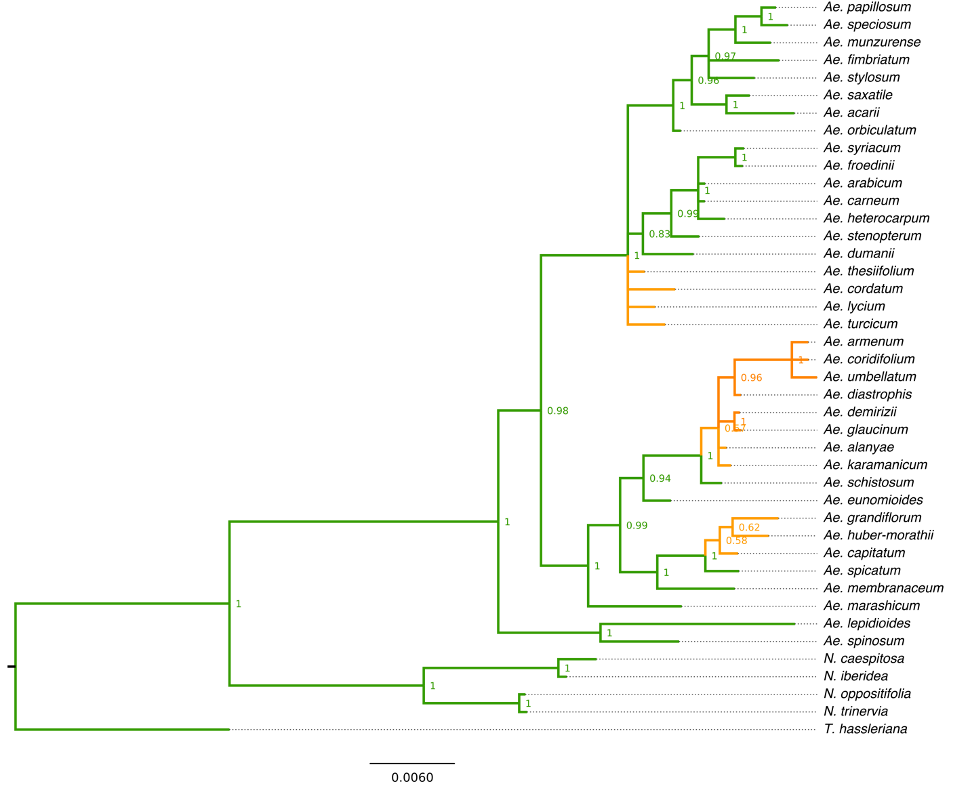

Fig. S2 RaxML tree of the Aethionemeae. Green edges: bootstrap > 80%. Orange edges: bootstrap <80%.

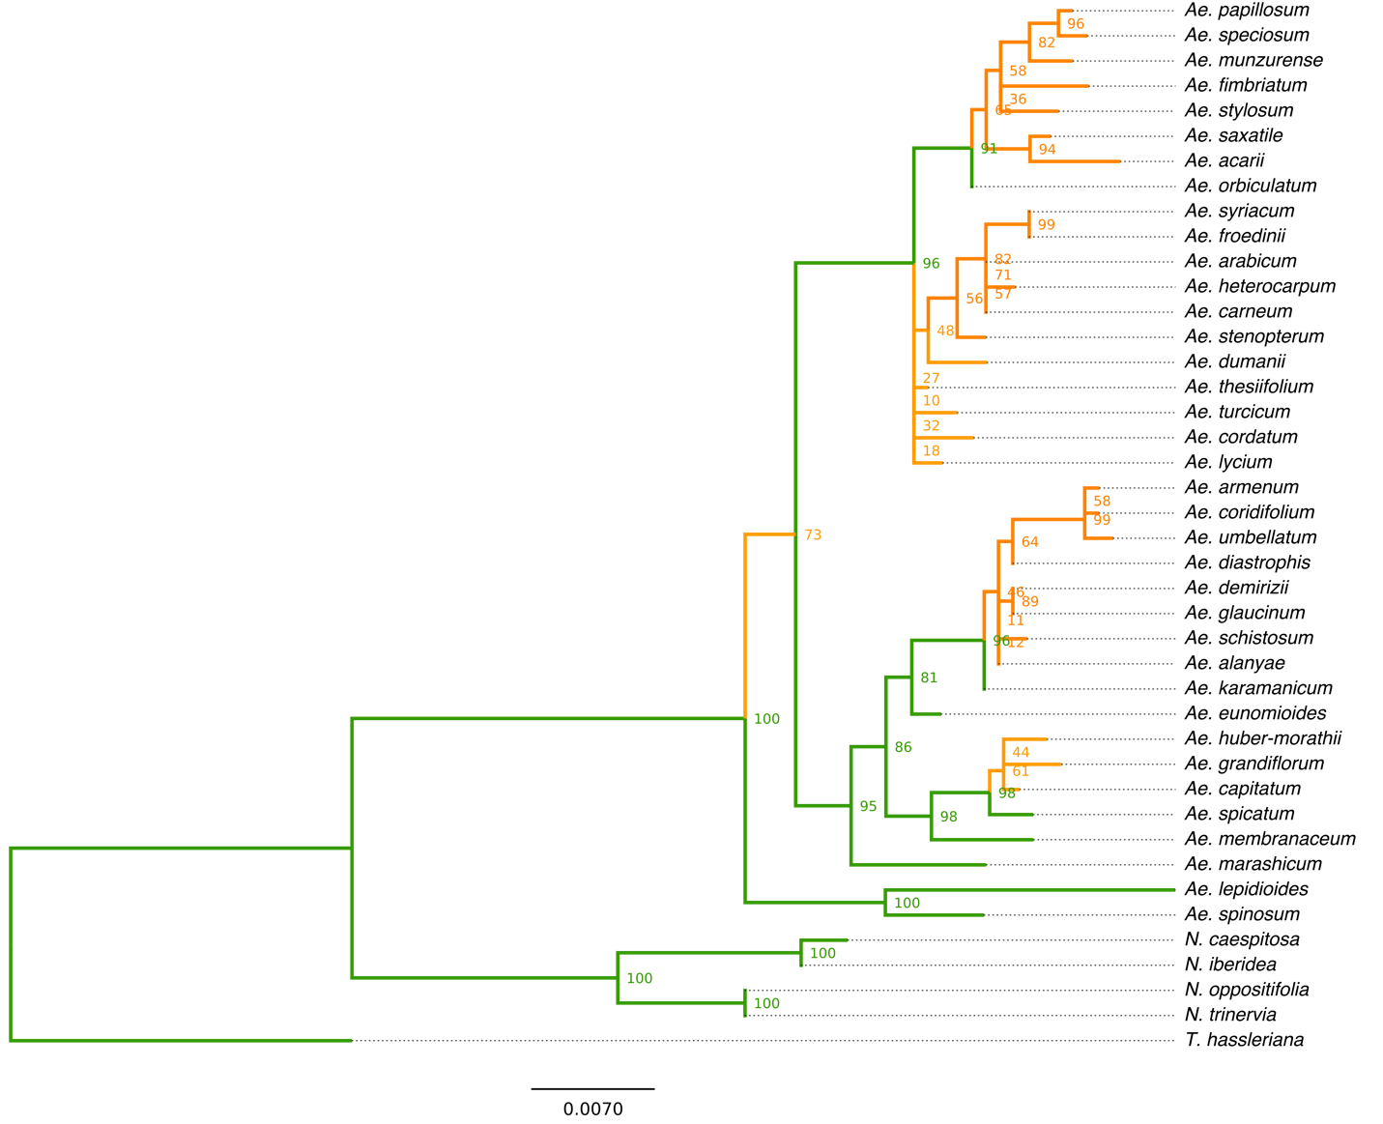

Fig. S3 Fruits of Aethionema arabicum fall into two discrete clusters. Dendrogram of the hierarchical cluster analysis based on length, width and seed number of 140 Ae. arabicum fruits. The cluster analysis was performed with SPSS 20 applying average between-group linkage method using squared Euclidean distance measurement. All fruits clustering in group 1 (light brown) developed no septum and produced non-mucilaginous seeds (indehiscent fruits), whereas all fruits clustering in group 2 (dark brown) developed a septum and produced mucilaginous seeds (dehiscent fruits).

Fig. S4 Phylogenies of Ae. arabicum orthologs of A. thaliana fruit developmental genes. A. thaliana query sequences are labeled in green. Identified Ae. arabicum orthologs are labeled in blue. Each tree was constructed using Quicktree-SD (neighbor joining) with 1,000 bootstrap replicates. A. AP2-like proteins including AP2. B. bHLH transcription factors (TFs) including ALC and IND. C. YABBY TFs including FIL. D. MADS-domain TFs including SHP1, SHP2, and FUL. E. Homeo-domain TFs including RPL. A list of all species and sequences used for gene phylogeny reconstruction is provided in Table S2.

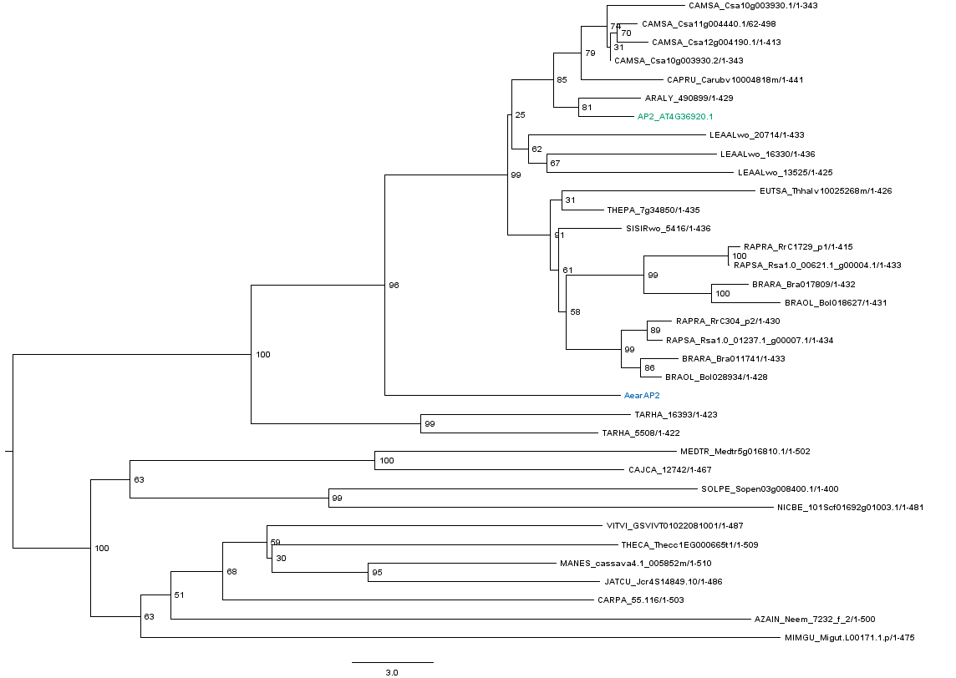
A

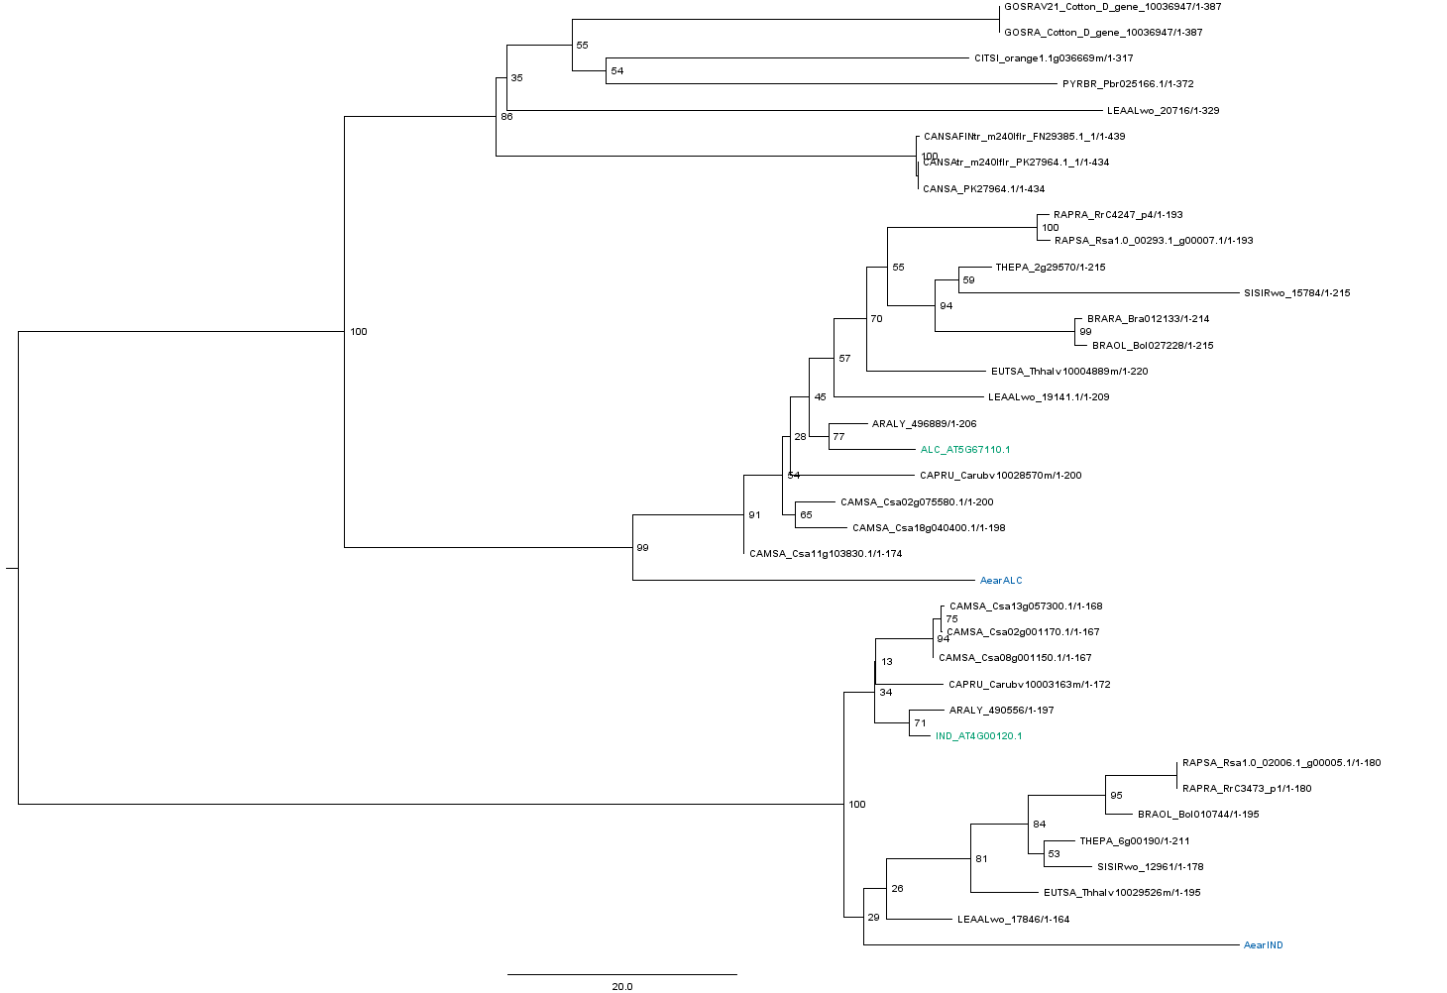
B

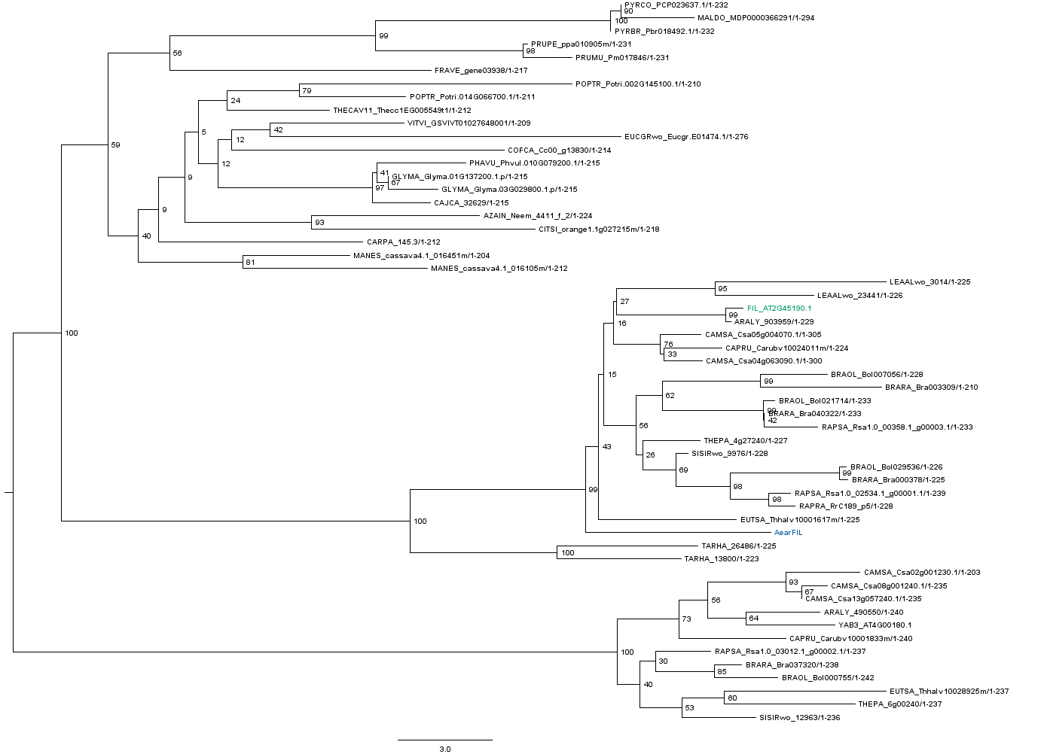
C
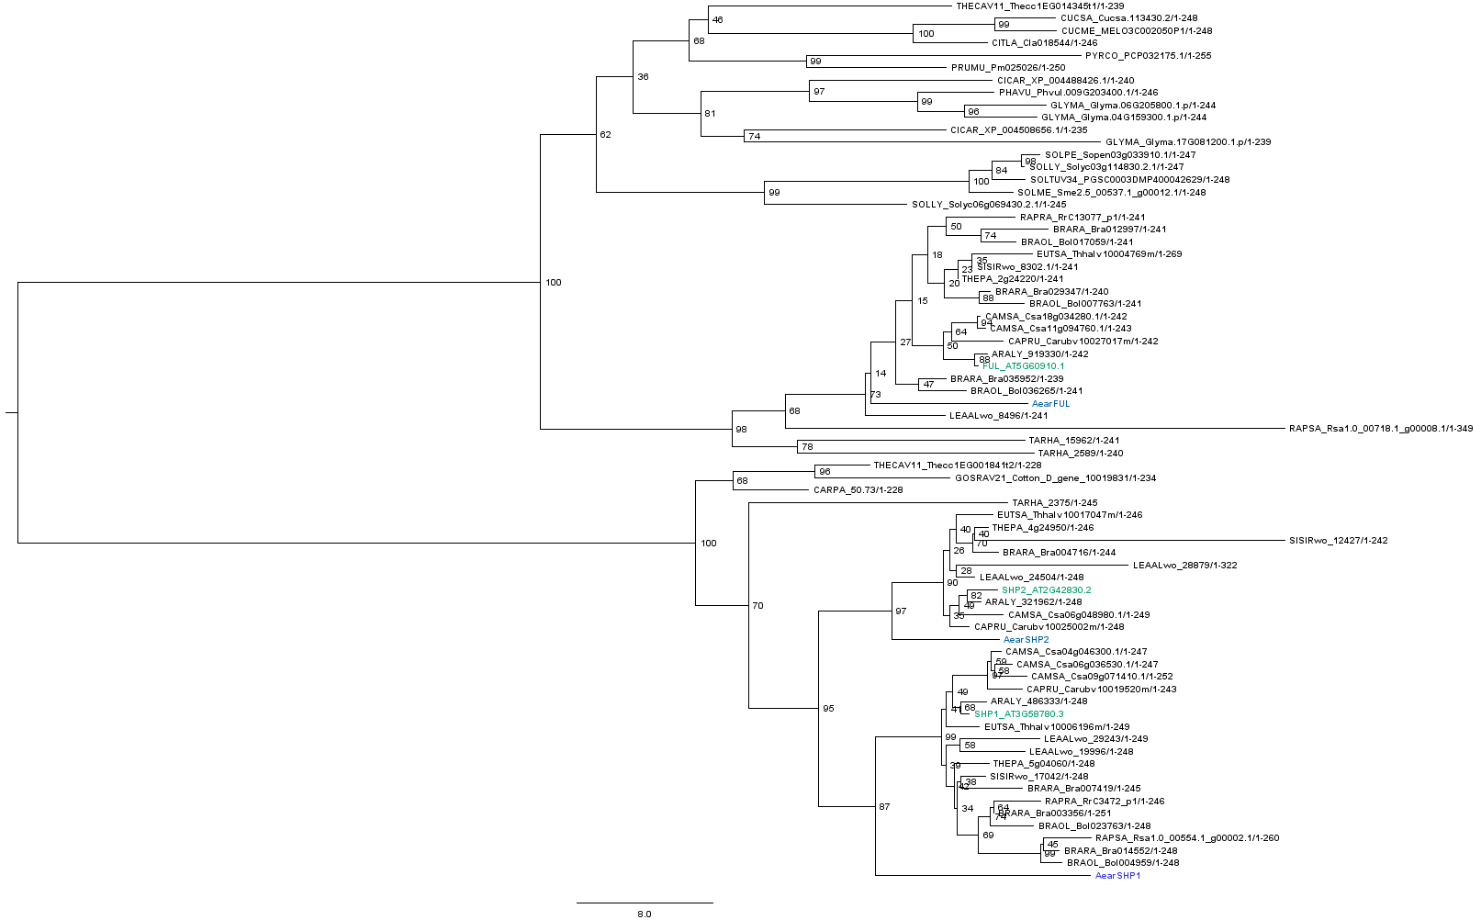
D

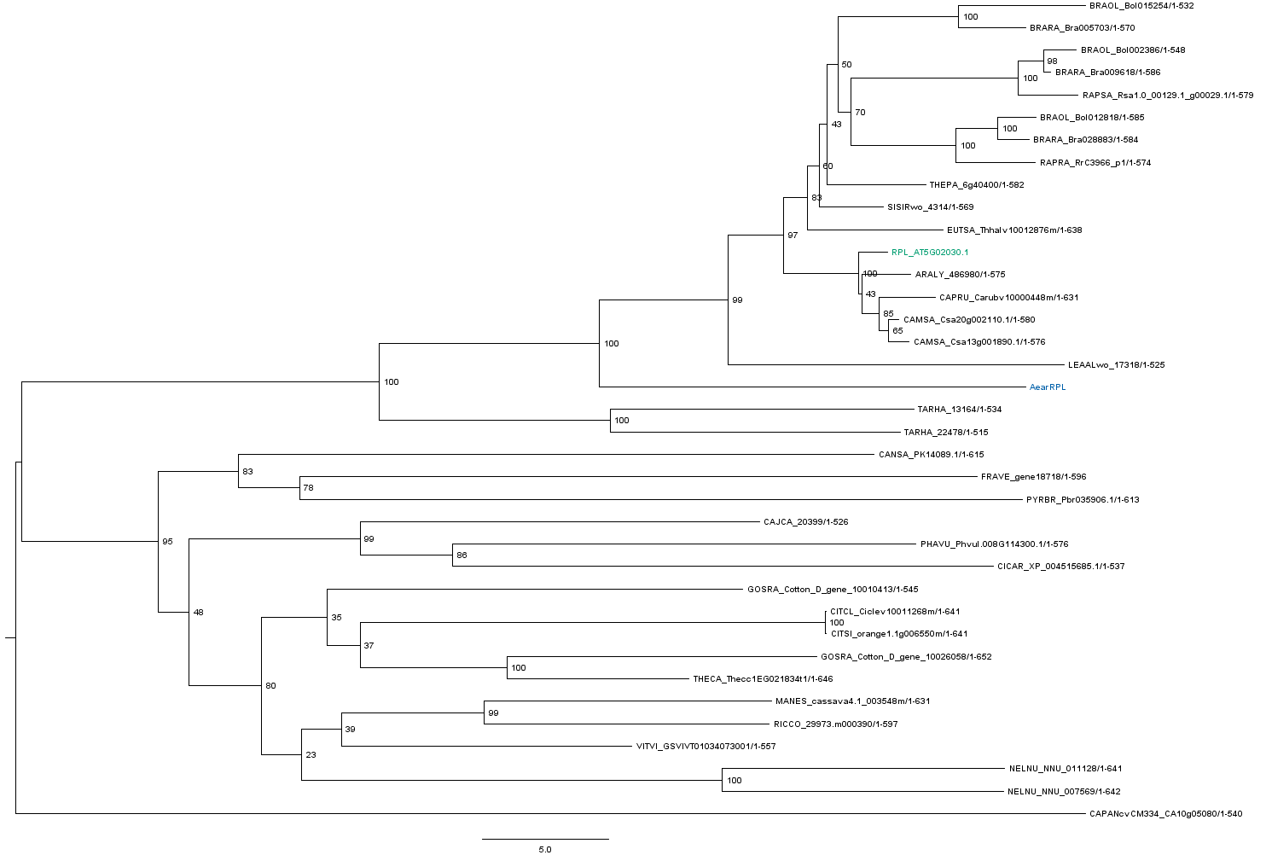
E

Fig. S5 The temperature-induced shift in fruit morph ratio is brought about by changes throughout the whole plant. The ratio (upper row) and total number (lower row) of fruits belonging to the dehiscent (grey bars) or indehiscent (black bars) fruit morph is reported for plants grown at a constant temperature of (a) 20°C or (b) 25°C. Fruits grown on the main stem, 1st, 2nd, or 3rd-order branches were scored individually. Bars represent means with standard deviation.

Table S1 Geographic origin of Aethionemeae species used for the phylogeny.
Species | Collector and number | Location
Ae. acarii | Y. Gemici 7694 | Kütahya, Turkey
Ae. arabicum | - | Ankara, Turkey
N. caespitosa | B. Özüdoğru 1138 | Sivas, Turkey
Ae. capitatum | A.A. Dönmez 4494 | Mersin, Turkey
Ae. carneum | TNRC 2636 | -
Ae. cordatum | M.E. Schranz 20.1 | Ankara, Turkey
Ae. coridifolium | A.A. Dönmez 5371 | Erzincan
Ae. demirizii | N. Adıgüzel 3010 | İçel, Turkey
Ae. diastrophis | Ö. İnceoğlu | Ankara, Turkey
Ae. dumanii | M. Vural 4162 | Ankara, Turkey
Ae. eunomioides | H.D & Z.A 4300 | Kayseri, Turkey
Ae. fimbriatum | A.A. Dönmez 9707 | Hakkari, Turkey
Ae. froedinii | A.A. Dönmez14361 | Diyarbakır, Turkey
Ae. glaucinum | N. Adıgüzel 3131 | Niğde, Turkey
Ae. grandiflorum | E. Schranz 2.2 N. | Chalus, Iran
Ae. heterocarpum | A.A. Dönmez 5094 | Şanlıurfa, Turkey
Ae. huber-morathii | N. Adıgüzel 3007 | Seyhan, Turkey
N. iberidea | A.A. Dönmez 11989 | Bitlis, Turkey
Ae. karaminicum | K. Ertuğrul 1215 | Karaman, Turkey
Ae. lepidioides | N. Adıgüzel 4992 | Sivas, Turkey
Ae. lycium | N. Adıgüzel 3254 | Antalya, Turkey
Ae. marashicum | B. Yıldız 1037 | Kahramanmaraş, Turkey
Ae. membranaceum | N. Adıgüzel 3938 | Van, Turkey
Ae. munzurense | P.H. Davis 31296 | Tunceli, Turkey
N. oppositifolia | A.A. Dönmez 6119 | Erzincan, Turkey
Ae. orbiculatum | D. Phitos 1963 | Greece
Ae. papillosum | Balls 1096 A.A. | -
Ae. saxatile | AY122451 | NCBI Genbank
Ae. speciosum | B. Yıldız 1354 | KahramanMaraş, Turkey
Ae. spicatum | N. Adıgüzel 3135 | Niğde, Turkey
Ae. schistosum | A.A. Dönmez 13862 | Antalya, Turkey
Ae. stenopterum | E. Schranz 2.10 | Chalus, Iran
Ae. stylosum | N. Adıgüzel 3121 | Niğde, Turkey
Ae. syriacum | A.A. Dönmez 10742 | Siirt, Turkey
N. trinervia | A.A. Dönmez 11001 | Bitlis, Turkey
Ae. thesiifolium | N. Adıgüzel 5233 | Burdur, Turkey
Ae. turcicum | N. Adıgüzel 2789 | Ankara, Turkey
Ae. umbellatum | E. Schranz 20.5 | Chalus, Iran
Ae. spinosum | E. Schranz | -
Tarenaya hassleriana | DQ649093.1 | NCBI GenBank

Table S2 List of species and respective sequences used for gene phylogeny reconstruction. (Provided as an additional Excel file)

Table S3 List of primers used for quantitative RT-PCR analysis.
Primer name | Primer sequence from 5’ to 3’
AearACT2 for | AATTGAGCATGGTGTGGTCA
AearACT2 rev | GCTCTTCAGGAGCAATACGG
AearAPC2 for | TCTCCTGCAATCGAGGACTT
AearAPC2 rev | GCAGTGAGCAACCGGTATTT
AearUBQ10 for | GAGGATGGCCGAACATTG
AearUBQ10 rev | TGCCCGTTAGGGTTTTGA
AearIND for | TGAATTGGAGCAAAGGAGCTA
AearIND rev | AAAGGGGAAGTGTGGAGTGAT
AearSHP1 for | GAAAGGCATAAGTCGCGTTC
AearSHP1 rev | TGTTGCAACTCCATTTCTCG
AearSHP2 for | ACAAATCGGCAAGTTACGTTCT
AearSHP2 rev | GAGCAACTTCAGCATCACACA
AearALC for | CGGTTATGCAACCAACACAG
AearALC rev | TCATACTGATTGAGCTGCGAGT
AearFUL for | AGAACAAGATCAATCGGCAAG
AearFUL rev | GAGCAACTTCAGCATCACAAAG
AearRPL for | CTGAGCCGTTTCAGAGATTTG
AearRPL rev | CCCTTCATAACCTCCACCACT
AearAP2 for | ACAAAGGAGGAATTTGTTCACG
AearAP2 rev | CGGCCACATTTATGCAAAGTA
AearFIL for | TCCTGCTTCTAACCAGCTTCA
AearFIL rev | TTGTTGGTGCATCTCTCAGC

Data S1 Sequence alignment underlying species phylogeny. (Provided as an additional Nexus file)

Video/Movie S1 Moisture induced pedicel movement of an Aethionema arabicum infructescence. For better overview, indehiscent fruits and fruit valves of dehiscent fruits have been removed. Maximal outward bending of pedicels occurs 20-30 minutes subsequent to water spraying. Pictures were taken every 30 sec.

